AD23532 – PRINCIPLES OF DATA SCIENCE
EXPERIMENT 6B: TIME SERIES DATA ANALYSIS AND FORECAST

QUESTION:
An airline company maintains monthly records of the number of passengers travelling by air. Analyze historical airline passenger data to identify trends, seasonality, and outliers, test stationarity using the Augmented Dickey-Fuller (ADF) test, build an ARIMA forecasting model, predict future passenger numbers, and evaluate the forecasting accuracy.

AIM:
To perform time series analysis and forecasting on the Airline Passengers dataset using Python by examining trends and seasonality, testing stationarity using the ADF test, applying differencing when required, building an ARIMA model, and evaluating predictions using MAE, MSE, and RMSE.

ALGORITHM:
- Import the required Python libraries, including Pandas, NumPy, Matplotlib, Statsmodels, and Scikit-learn.
- Load the Airline Passengers dataset with the date column as a datetime index and display the dataset information and summary statistics.
- Plot the original time series to observe trends, seasonality, and possible outliers.
- Perform the Augmented Dickey-Fuller (ADF) test to determine whether the series is stationary.
- If the series is non-stationary, apply differencing and repeat the ADF test until stationarity is achieved.
- Split the original time series chronologically into training and testing datasets.
- Build an ARIMA model using the selected differencing order and fit it on the training data.
- Forecast passenger numbers for the test period and calculate MAE, MSE, and RMSE.
- Plot the training data, testing data, and predicted passenger numbers in a single graph.
- Interpret the forecasting results and evaluate the model's performance.

PROGRAM & OUTPUT:
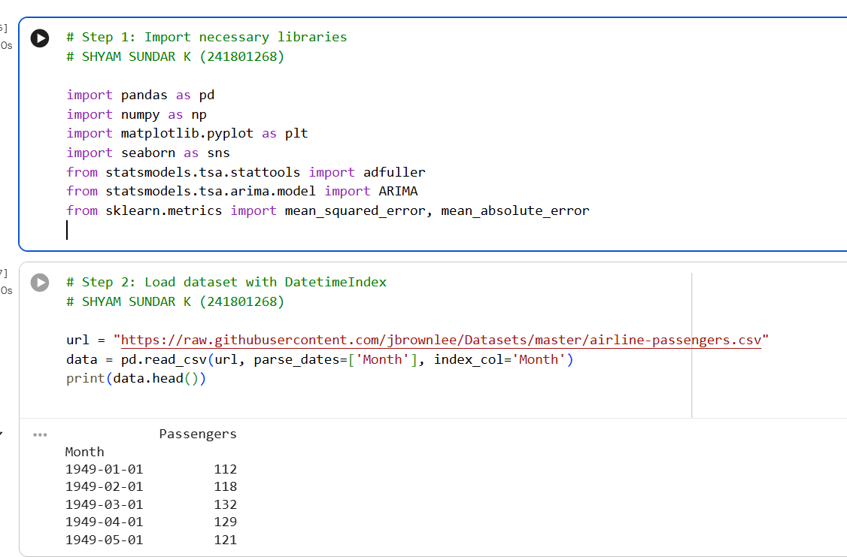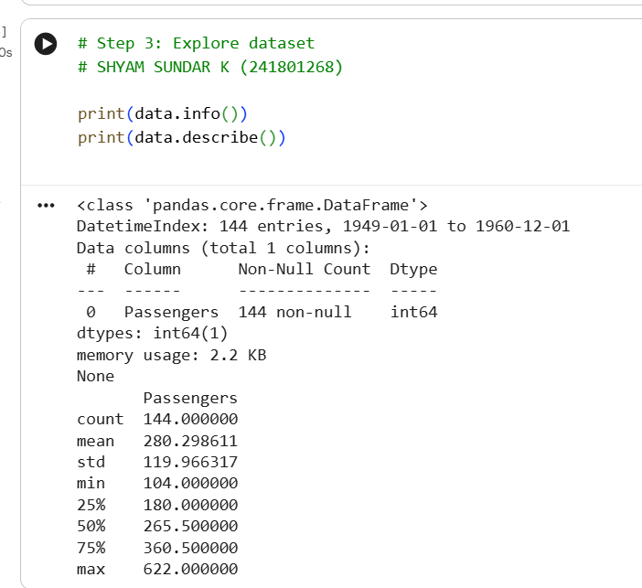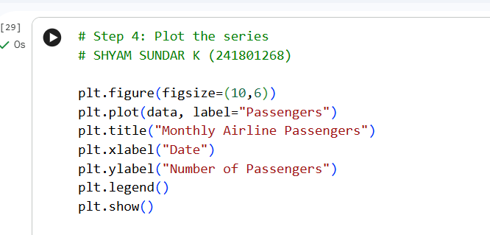
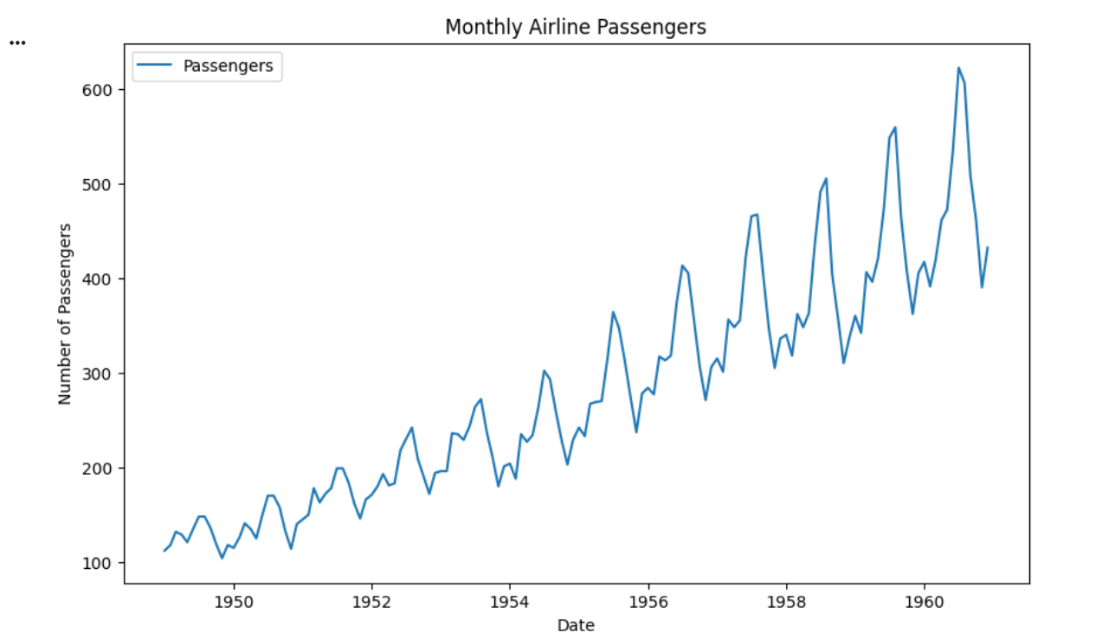
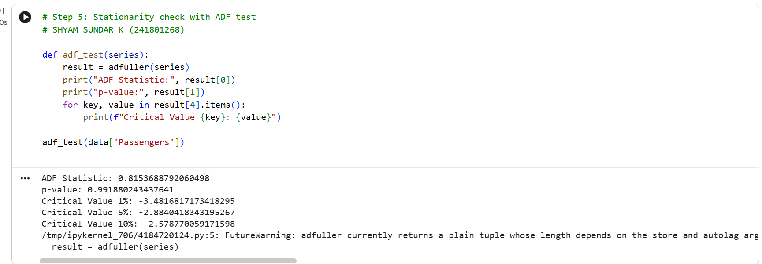
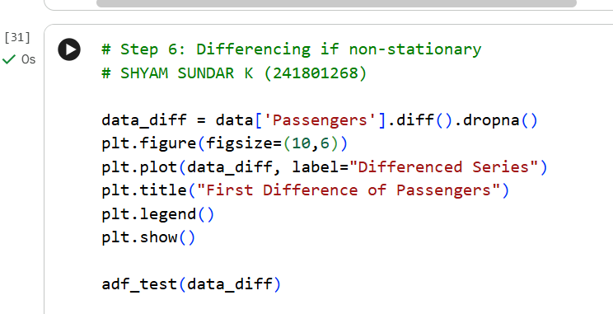
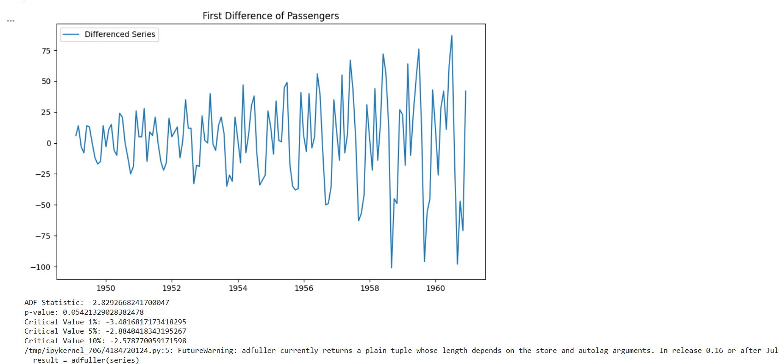
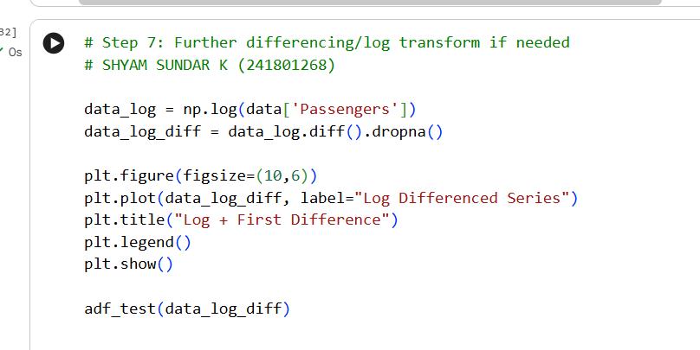
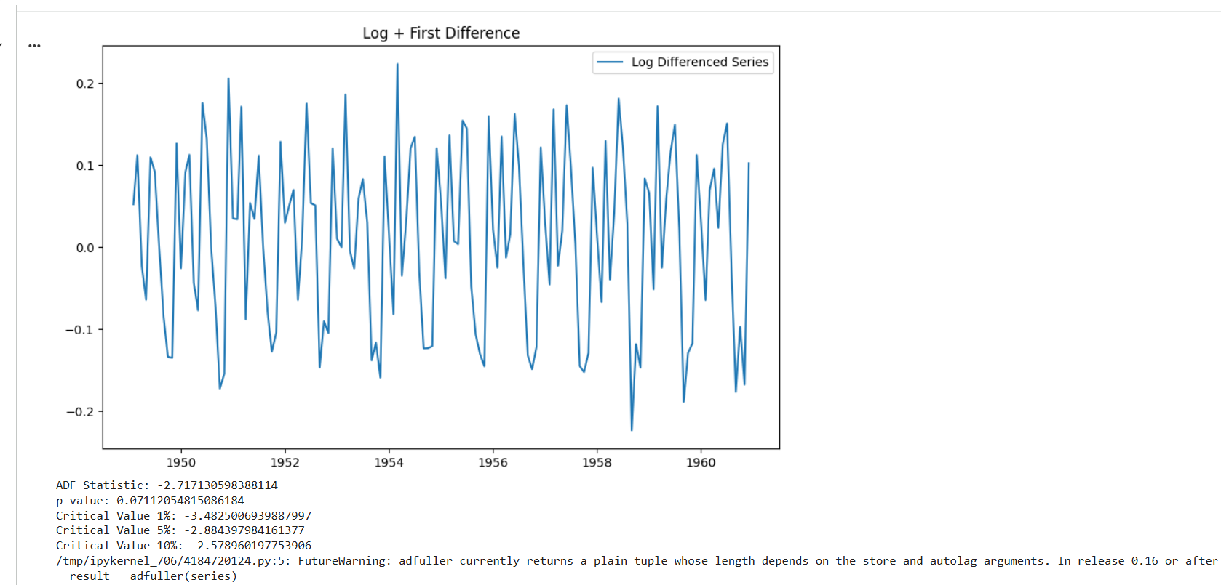
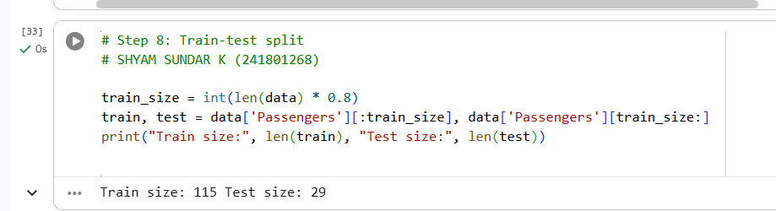
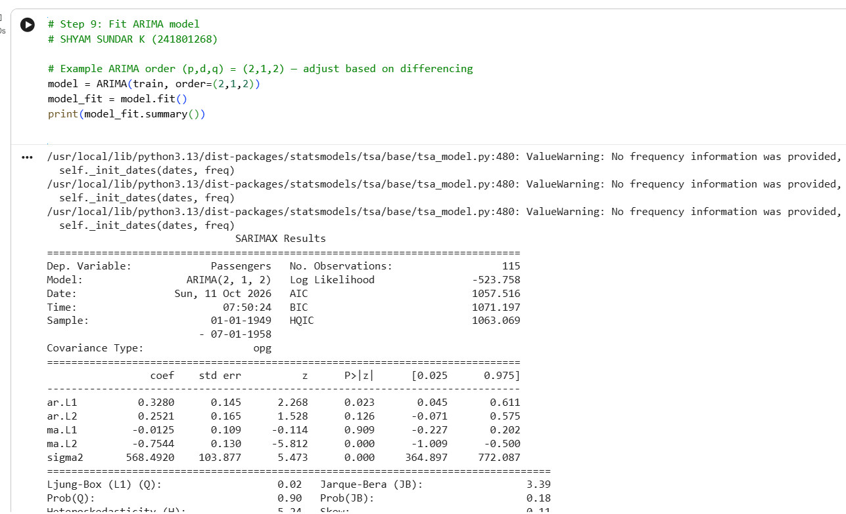
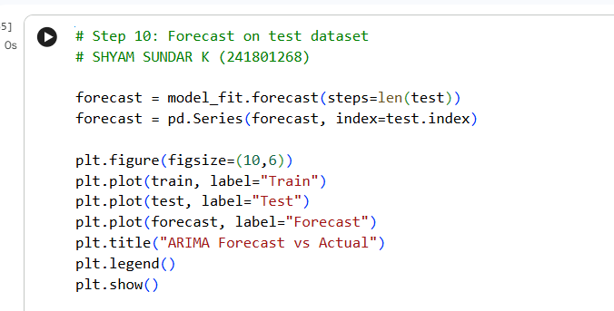
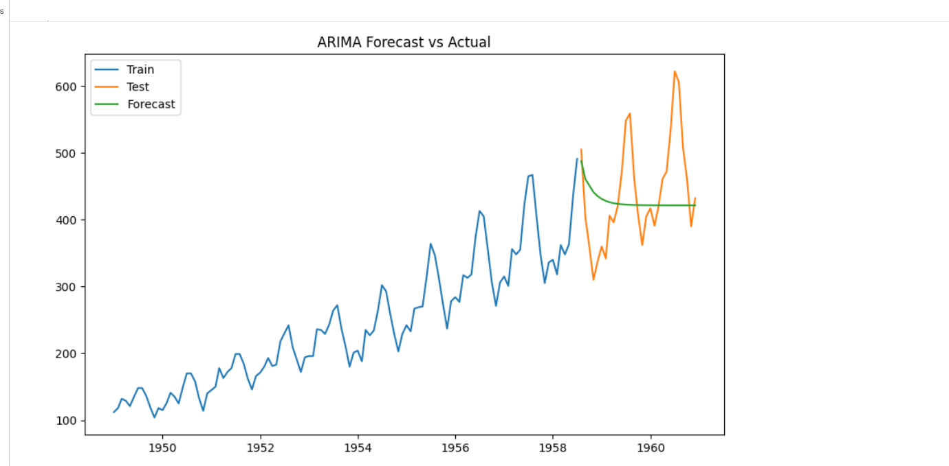
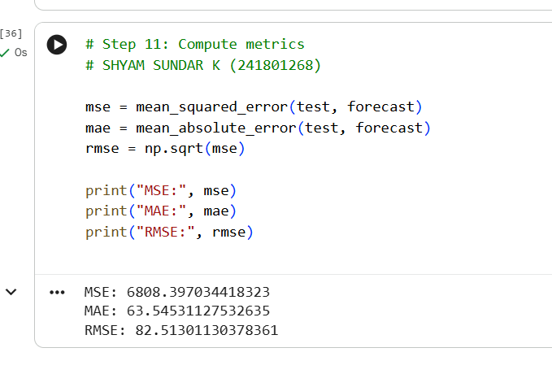

RESULT:
Thus, time series analysis and forecasting were successfully performed on the Airline Passengers dataset using Python. The stationarity of the time series was evaluated using the Augmented Dickey-Fuller (ADF) test, and differencing was applied when required. An ARIMA model was built to forecast passenger numbers, and its performance was evaluated using MAE, MSE, and RMSE. The actual and predicted passenger values were visualized to assess the forecasting accuracy.

